  For office use only
  T1 | ________________
  T2 | ________________
  T3 | ________________
  T4 | ________________
  Team Control Number
  20048
  Problem Chosen
  A
  For office use only
  F1 | ________________
  F2 | ________________
  F3 | ________________
  F4 | ________________
2013
Mathematical Contest in Modeling (MCM/ICM) Summary Sheet
(Attach a copy of this page to your solution paper.)
The Ultimate Brownie Pan
Summery
While baking a product, it is a commonplace phenomenon that the product is not evenly heated and the space in an oven is not used efficiently. In this thesis two models are thus established to determine the optimum pan for the purpose of making full use of the space in an oven under the condition that the product is not locally overcooked.
As the first step, the edge thermal distribution model (the first model) is developed on the basis of common relations in transfer process in nature, and the rule that in the transfer process the rate is proportional to the driving force of the process and is inversely proportional to the resistance of the process. Then a NavInfo is built by this model showing the distribution of edge temperature with regard to time and the location for pans ,which are different in shapes- rectangular to circular and other shapes in between. The result demonstrates that the four corners of the rectangular pan tend to locally overcook the product while in a circular one the product is evenly heated.
Based on the first model, a thought has been hereby obtained , the closer the pan is to circular in shape, the more even it will be when the pan is being heated(平底锅接受热量). Under the conditions above, the circular degree ( )of objects of arbitrary shape is defined and is used as an index to measure the heating uniformity of the pan. N stands for the number of pans, H for the heat distribution uniformity, and p for the weight coefficient. As the next step, integrated function f is defined:
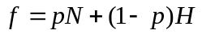
Best pans and oven matching model (the second model) has been built by completing the following work. To start with, f is assigned as the objective function. After that, constraint condition is established by searching for rough range of sizes in online shops selling pans. Afterwards, 0.1 is set as the step change of p in [0.1,0.9], and the maximum value of f which corresponds to p in every condition as well as the corresponding W/L are obtained, (by using some optimize algorithm,perfectly found the optimum weight coefficient p which maximizes f )(and then p which maximizes f is regarded as the optimum weight coefficient). With the optimum weight coefficient, the optimum resulting parameter of the size of pans is:
The model developed can be used not only to determine the ultimate pan, but also to select the most efficient oven which matches the pan. Once the information of the oven’s size the customer requires is available, the optimum pan can be hereby designed through the model.

Keywords:edge thermal distribution model , weight coefficient , Best pans and oven matching model

Content

- Introduction
1.1 Background
While baking in a rectangular pan, heat is focused in the 4 corners and the product gets overcooked at the corners, if not to such an extent, at the edges. By contrast, in a round one the heat is distributed evenly over the entire outer edge and the product is not overcooked at the edges. However, since most ovens are rectangular in shape, consequently, when it comes to making use of the space in an oven, using round pans is not efficient. In order to design a ultimate brownie pan which matches the oven and product, we need to fulfill some tasks.
The first task is to establish a model to demonstrate the distribution of heat across the outer edge of a pan for pans of different shapes which include rectangular, circular and other shapes in between.
1.2 Restate of the Problem
The former part of the thesis is committed to make certain the temperature distribution of products of different shapes in an oven. Nevertheless, pan that relatively uniformizes the temperature distribution of the product will not necessarily make full use of the space in an oven. In the latter part, effort is made to find out the optimum pan that makes the product heated evenly and at the same time takes advantage of the space in the oven to the fullest. In order to design the optimum pan, the following tasks must be accomplished.
1. retrieve the data of experiments carried out before and build the first model according to the basic disciplines of thermodynamics and then deduce the rule of temperature distribution of rectangular, circular and shapes in between.
2. consider the structure size of the pan on the basis of the rule of temperature distribution obtained by the first model meanwhile taking into account the temperature uniformity while baking the product. Before the optimum structure size of the pan is acquired, there is a need to search for the average range of the structure size of the pan in online shops, and then a constrained programming model (the second model) must be developed by which to select the optimum pan.
2. Assumptions
The first assumption: the oven performs steadily in the working process.
In other words, on one hand, the power supply of the oven in the working process is steady, excluding any emergency such as a power failure. On the other hand, all the parts of the oven works normally and there is no possibility that components break down. It is completely meaningless to probe into the situation where an oven that can not work normally is used.
The second assumption: the width and length of the pan can be regarded to be close to those of the oven.
The assumption is made by considering the full use of the space in an oven. It is certain that the shapes of small and large pans can be different and generally, the shape of the small pan taken into account is between rectangular and circular.
The third assumption: the product can be baked to be ripe under the temperature set by the oven.
If the product in the oven fail to be ripe, it is possible that the highest temperature the oven can reach is too low or the product has an even higher requirement for temperature. It is of no meaning to discuss the temperature distribution in the oven and to design the optimum pan if the product can not be baked to be ripe.

3.Our Model
2.1 Model 1: the model of temperature distribution
The common rule of transfer process in nature is that in the transfer process the rate is proportional to the driving force of the process and is inversely proportional to the resistance of the process. The rate of heat transmission can be expressed as: heat transfer rate=heat transfer driving force (temperature difference)/heat transfer resistance. It can be deduced by the discipline that heat conduction rate Q can be expressed as [1]:
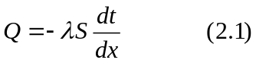
In the formula, stands for thermal conductivity, and represents the sectional area of heat transmission. When the material of the wall is uniform, thermal conductivity varies little with the change of temperature. But in many cases the product not yet baked is not uniform in the combination of materials. For the purpose of showing this kind of change, we assign as linear with regard to. For a specific product, it is advised that an experiment should be implemented if possible to measure how changes when varies.
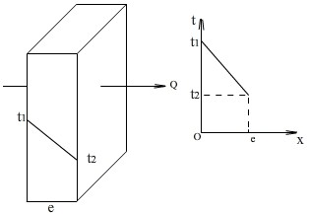

Figure 2.1: Singer-layer flat wall heat transfer
What the first picture illustrates is the situation of single flat wall heat transfer, that is, heat transfers from side of high temperature to that of low temperature. Following steps can be acquired through integration based on formula (1):
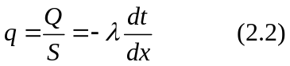
When linear change with ,we have:
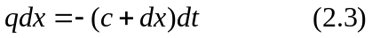
From formula (2.3) and Figure 2.1, can hereby be obtained as:
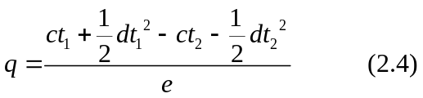
Replace with and with , and the formula of single flat wall heat transfer is hereby acquired as:
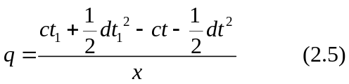
The second picture is to analyze the rectangular product’s conducting heat. When Top convective fan speed and Bottom convective fan speed are both 0, temperature is assigned as 180°C, and when the baking time is 6 min, temperatures of Top, Side, Bottom are 104,81,101 °C respectively. The larger cuboid is the product, and the smaller cuboid whose vertex is O is set as the subject being heated.
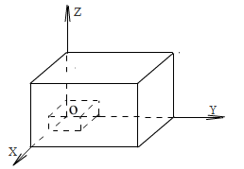
Figure 2.2: Three-dimensional objects thermal analysis
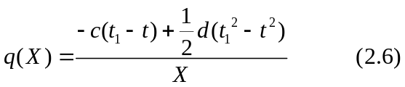

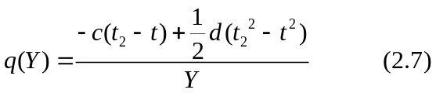
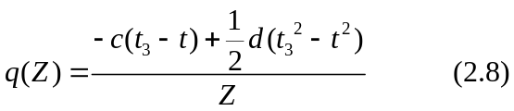

Among them, 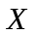,,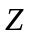 are distances between infinitesimal and planes 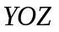，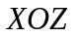,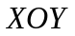.
, , are the average temperatures of planes ，, of the pan.
To simplify the process of heat transfer, is assigned as the room temperature.
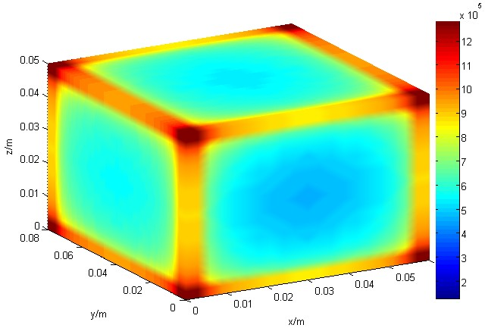
Figure 2.3: The rectangular product heat distribution

The third picture explicitly illustrates that in a rectangular pan, the four corners get more heat per unit area than other positions, so it can be concluded that the corners of the rectangular pan tend to be overheated locally. For baking a product, when the product is locally overheated, there are two possible results. If the baking time is too short, the part that is locally overheated will be ripe while other parts are not. If baked for too long a time, the product will be entirely overcooked. Consequently, local uneven heating is not a favorable result.
 | 0.00 | 0.80 | 1.60 | 3.20 | 4.40 | 5.60 | 6.80 | 8.00
0.00 | 1579.26 | 1559.26 | 1529.26 | 1499.23 | 1479.23 | 1509.26 | 1539.26 | 1579.26
0.60 | 1094.45 | 861.35 | 721.49 | 686.52 | 674.87 | 694.85 | 744.80 | 1094.45
1.50 | 983.58 | 750.48 | 610.62 | 575.66 | 564.00 | 583.98 | 633.93 | 983.58
2.40 | 955.86 | 722.76 | 582.90 | 547.94 | 536.28 | 556.26 | 606.21 | 955.86
3.30 | 946.63 | 713.53 | 573.67 | 538.70 | 527.05 | 547.03 | 596.98 | 946.63
4.20 | 962.46 | 729.36 | 589.50 | 554.54 | 542.88 | 562.86 | 612.81 | 962.46
5.10 | 1002.06 | 768.96 | 629.10 | 594.13 | 582.48 | 602.46 | 652.41 | 1002.06
6.00 | 1279.23 | 1046.13 | 906.27 | 871.30 | 859.65 | 879.63 | 929.58 | 1279.23

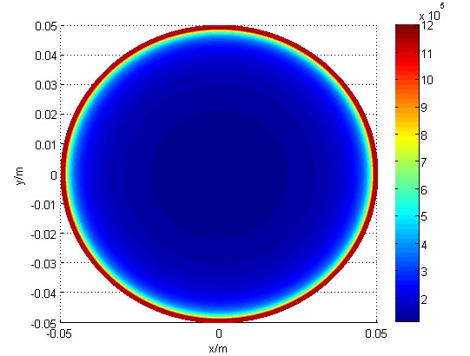
Figure 2.4:The section heat distribution of round product
The fourth picture is the section of a picture that a circular pan is being heated. Apparently, the outer edge of the circular pan is evenly heated and the phenomenon of local uneven heating that arises while using a rectangular one is thus avoided.
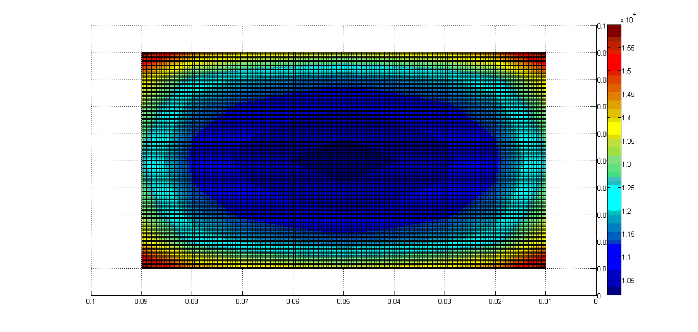
Figure 2.5:The section heat distribution of the shape between rectangular and round

2.2 Model 2:Best pans and oven matching model
For one thing, the space of the two racks in the oven must be made full use of. For another, the uniformity of heating the product on the pan should also be taken into consideration. In a general way, the four corners of a product on a rectangular pan are easily overheated, which can be avoided by using a circular one. In other words, by using a circular pan, the product being baked can be heated more evenly. To quantify the index (namely, the uniformity of heating the product), the concept of circular degree must be defined.
2.2.1 Circular degree
In the principles of chemical industry, for an object of arbitrary shape, the sphericity of the object is defined as 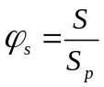, in which stands for the surface of the ball whose volume amounts to the object and 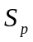 represents the surface of the object. Similarly, the circular degree can be defined.
As the picture below shows, it is a flat object without thickness, on whose contour line the maximum value of distance between any two points is 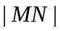, the circular degree is defined as 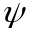=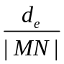, in which 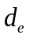 represents equivalent diameter and 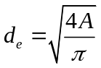, 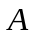 stands for the thickness of the flat object. In a rectangular whose length is and width is , when cutting a sector of relatively small area, for convenience, the current circular degree is defined as 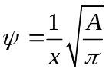. Based on the conclusion drawn by the first model, the circular pan is heated more evenly than non-circular one. Therefore, the uniformity of heating 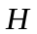 can be replaced by the circular degree.
2.2.2 Shapes in between
The picture below presents a rectangular Brownie pan which overheats the product while baking. It is not the customer wants.
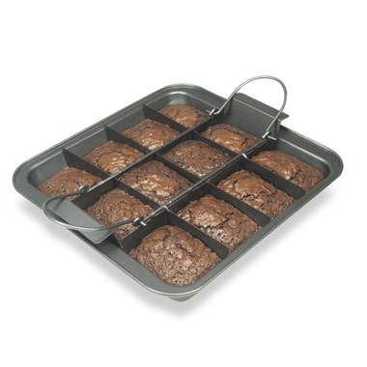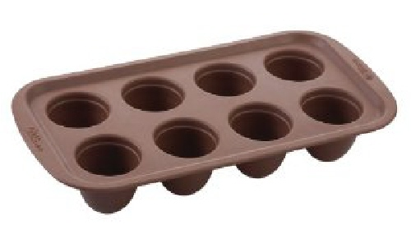
Figure 2.6:rectangular brownie pan Figure 2.7 round brownie pan
The picture below shows a circular Brownie pan whose merit is that it heats the product evenly and it produces aesthetic food. The shortcoming is that much space of the pan is not efficiently used.
As the picture below demonstrates, the length (PQ) of rectangular MPQN is 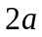, the width (MP) is 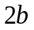, W and S are points of intersection of oval ACBD and rectangular MPQN in the first quadrant, and the horizontal ordinates of W and S are 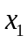 and 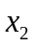(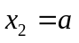) separately. WSQZZ’R’S’W’W are the shape between rectangular and circular. The equation of oval ACBD is:
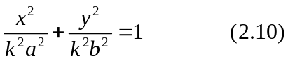

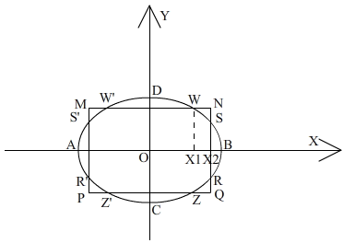
Figure 2.8: The shape between rectangular and round
In it, is an undetermined parameter greater than 0 and the shape of WSQZZ’R’S’W’W varies when changes. When the value of is 1, WSQZZ’R’S’W’W becomes an oval, and if at the same time the value of equals to that of , WSQZZ’R’S’W’W transforms into a circular. Consequently, it is rational to use WSQZZ’R’S’W’W to signal shapes between rectangular and circular.

The length of SX2 is assigned as , and the area of shapes between rectangular and circular can been expressed as:
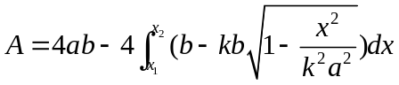
Additionally, since the points W and S are both on the oval, after plugging W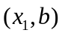 and S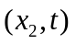 into the elliptic equation, an equation can be acquired as follows:
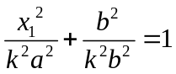

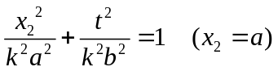
Then the expression of can be obtained as:

2.2.3 The establishment and solving of the model:
After consulting several online shops, the structure size of the oven can be set as follows:
Parameter | variation | Parameter | variation | Parameter | variation
L | 0.25 | a | 0.0025 | N1 | 1
 | 0.50 |  | 0.06 |  | 10
w | 0.15 | b | 0.15 | N2 | 1
 | 0.30 |  | 0.04 |  | 10

The optimum pan
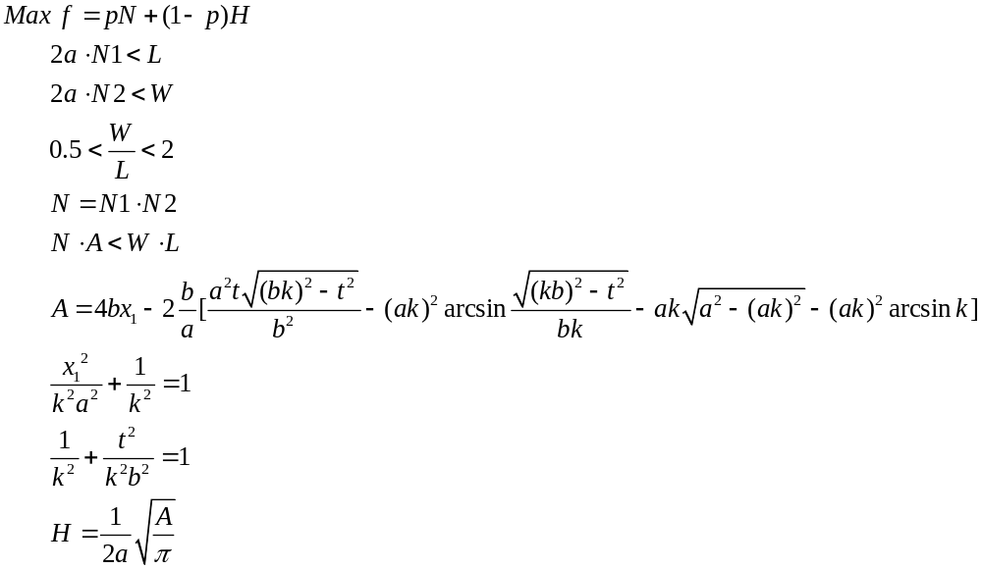

N | N1 | N2 | H | p | 1-p | W/L | f
6 | 6 | 1 | 3.05 | 0.1 | 0.9 | 0.775 | 3.345
15 | 3 | 5 | 2.66 | 0.2 | 0.8 | 0.654 | 5.128
10 | 2 | 5 | 2.33 | 0.3 | 0.7 | 0.588 | 4.631
18 | 9 | 2 | 2.92 | 0.4 | 0.6 | 0.586 | 8.952
16 | 2 | 8 | 2.43 | 0.5 | 0.5 | 0.915 | 9.215
21 | 3 | 7 | 2.76 | 0.6 | 0.4 | 0.839 | 13.704
24 | 6 | 4 | 4.32 | 0.7 | 0.3 | 0.993 | 18.096
21 | 7 | 3 | 1.79 | 0.8 | 0.2 | 1.786 | 17.158
18 | 3 | 6 | 3.62 | 0.9 | 0.1 | 0.618 | 16.562

By using 1stopt for programming it can be obtained how changed when 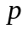 varies. The changes are illustrated in the chart below:

Model testing and sensitivity analysis
Since generally the structure sizes of ovens of different brands are not the same, the optimum W/L obtained is not necessarily fitting to that of the customer’s oven. The optimum W/L obtained by the model only works in designing matched ovens and pans. But, if the customer only needs to purchase a pan, as long as he informs the manufacturer of the structure size of his own oven, the manufacturer can therefore use the model built to select the most suitable pan for him.

Strengths and weaknesses discussion
The advantages of the models: in the first model, in accordance with the process transfer law, the phenomenon of single flat wall heat conduction is studied in the first place, whose result is then used in the three-dimensional process of heat transmission. Eventually, the situation of heating in the objects of shapes of rectangular, circular and other shapes in between is explained. Under the instruction of the second model, the pan that is both capable of heating the product evenly and making full use of the space of the oven is thus designed.
The weakness of the models: there is a lack of analysis on thermal radiation’s heating the product, and a deliberate study on the rule of temperature distribution in different ovens is not realized.
Overall, the method established succeeds in providing a complete solution to designing the optimum pan, which can offer an effective theoretical basis for manufacturers to produce ovens as well as pans.

The reason to choose our brownie pan:
The pan designed according to our model is both aesthetic and symmetrical, which will avoid locally overheating the product in the oven thus overcooking it, in other words, to make the ripe product uniform in texture. On the premise that an even texture of the product is guaranteed, it is energy-saving and environmental-friendly to make use of the oven to the fullest.
For manufacturers, they can design the oven and the pan which are the best match by referring to our model.
For customers, they can choose the pan that is the fittest to their own oven once they are aware of the width and length of the oven. Meanwhile, the manufacturer is also able to inform the customers of the price of the pan (according to the manufacturing cost) for them to choose from.
The pan designed according to our model is both aesthetic and symmetrical, which will avoid locally overheating the product in the oven thus overcooking it, in other words, to make the ripe product uniform in texture. On the premise that an even texture of the product is guaranteed, it is energy-saving and environmental-friendly to make use of the oven to the fullest.
For manufacturers, they can design the oven and the pan which are the best match by referring to our model.
For customers, they can choose the pan that is the fittest to their own oven once they are aware of the width and length of the oven. Meanwhile, the manufacturer is also able to inform the customers of the price of the pan (according to the manufacturing cost) for them to choose from.

